TASK 3 – Design the Control Logic
Aim
To design the control logic for allocating a free parking slot and calculating the parking fee using Java.
1. Slot Allocation – Pseudocode
ALGORITHM AllocateSlot(vehicleNo)

1. FOR each floor f
2. FOR each slot s in floor f
3. IF slot is free THEN
4. Store vehicleNo in the slot
5. RETURN {f, s}
6. END IF
7. END FOR
8. END FOR
9. RETURN null
END ALGORITHM

2. Parking Fee Calculation – Pseudocode
The assignment does not specify exact parking rates. The following pseudocode uses an hourly rate and a daily maximum as examples.
ALGORITHM CalculateFee(minutes, ratePerHour)
1. IF minutes <= 0 THEN
2. RETURN 0
3. END IF
4. SET hours = (minutes + 59) / 60
5. SET fee = hours * ratePerHour
6. IF fee > dailyMaximum THEN
7. SET fee = dailyMaximum
8. END IF
9. RETURN fee

END ALGORITHM

3. Complete the Code – ParkingFacility.java
public class ParkingFacility {
// slots[floor][slot] holds a vehicle number, or null if free
private final String[][] slots;
public ParkingFacility(int[] slotsPerFloor) {
slots = new String[slotsPerFloor.length][];
for (int f = 0; f < slotsPerFloor.length; f++) {
slots[f] = new String[slotsPerFloor[f]];
}
}
/** Returns {floor, slot} of the first free slot, or null if full. */
public int[] allocate(String vehicleNo) {
for (int f = 0; f < slots.length; f++) {
for (int s = 0; s < slots[f].length; s++) {
if (slots[f][s] == null) {
slots[f][s] = vehicleNo;
return new int[]{f, s};
}
}
}
return null;
}
/** Frees a slot. Returns false if invalid or already free. */
public boolean release(int floor, int slot) {
if (floor < 0 || floor >= slots.length)
return false;
if (slot < 0 || slot >= slots[floor].length)
return false;
if (slots[floor][slot] == null)
return false;
slots[floor][slot] = null;
return true;
}
public static void main(String[] args) {
// floor 0 has 2 slots, floor 1 has 1 slot
ParkingFacility p = new ParkingFacility(new int[]{2, 1});
System.out.println(java.util.Arrays.toString(p.allocate("TN01AB1111")));
System.out.println(java.util.Arrays.toString(p.allocate("TN02CD2222")));
System.out.println(java.util.Arrays.toString(p.allocate("TN03EF3333")));
System.out.println(java.util.Arrays.toString(p.allocate("TN04GH4444")));
System.out.println(p.release(0, 1) + " " + p.release(0, 1) + " "
+ p.release(5, 0));
System.out.println(java.util.Arrays.toString(p.allocate("TN04GH4444")));
}
}
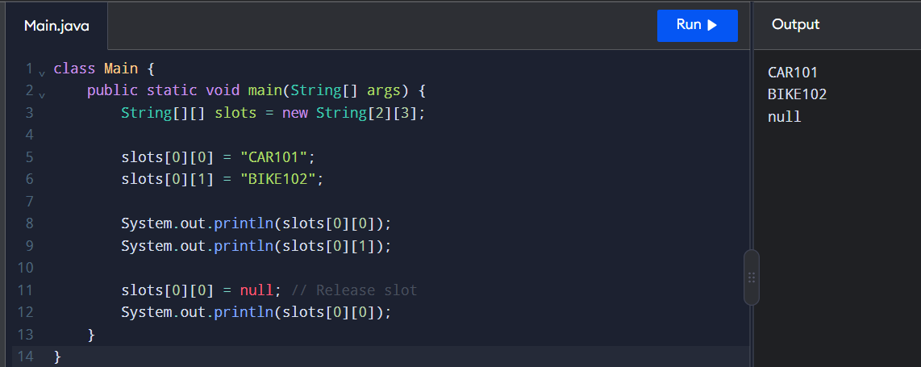

4. Expected Output
[0, 0]
[0, 1]
[1, 0]
null
true false false
[0, 1]

5. Explanation of Control Statements
- for loop: Searches each floor and each slot.
- if statement: Checks whether a slot is free or a position is valid.
- return: Returns the allocated position or stops the method when a free slot is found.
- break: Stops a loop when a condition is satisfied. It is not required in this implementation.
- continue: Skips the current iteration. It is not required in this implementation.

6. Handling a Full Parking Facility
If all parking slots are occupied, the allocate() method returns null. The calling program can display a message such as Parking Full.

7. Alternative Concept and Complexity Analysis
Let \(N\) be the total number of parking slots across all floors.
Operation | Nested-loop approach | Free-slot stack approach
Allocation | (O(N)) worst case | (O(1)) amortized
Release | (O(1)) | (O(1))
Extra space | (O(N)) for slot storage | (O(N)) for free-slot records
A free-slot stack stores available slot positions. Allocation removes a free position from the stack, while release adds the position back. This makes allocation faster, but requires extra logic to avoid duplicate entries and invalid releases.
The nested-loop approach is simpler and suitable for a beginner-level parking system.

Result
The parking slot allocation and release operations were implemented successfully using nested loops, conditional statements, and arrays. The program allocates the first free slot, rejects invalid releases, and returns null when the parking facility is full.

